# Calculate and Plot SMAs

📘 Simple 50-Word Explanation:

This code computes the 50-day Simple Moving Average (SMA) of Apple's closing stock prices using a rolling mean. The SMA smooths price data to highlight trends. It then plots both the 50-day SMA (in green) and actual close prices (in red) to help visually compare trends and price movements.

📊 Screenshot of the exercise:

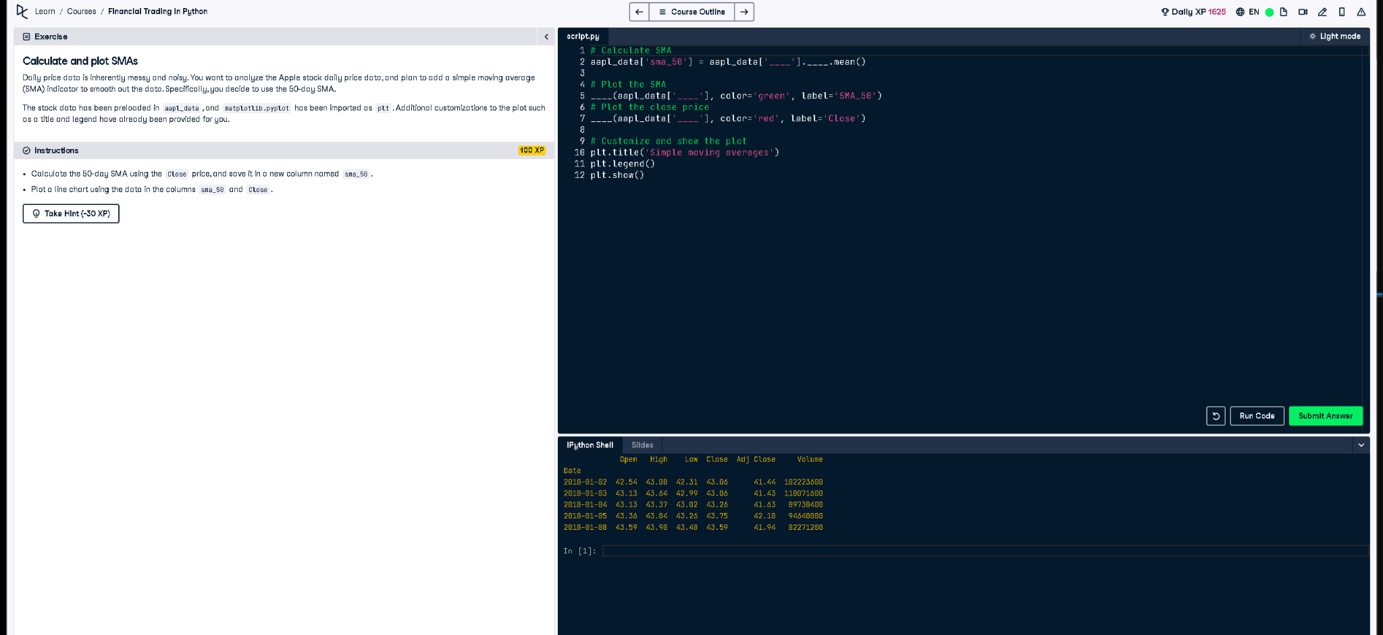

🐍 Full Python Code:

# Calculate SMA  
aapl_data['sma_50'] = aapl_data['Close'].rolling(window=50).mean()  
  
# Plot the SMA  
plt.plot(aapl_data['sma_50'], color='green', label='SMA_50')  
  
# Plot the close price  
plt.plot(aapl_data['Close'], color='red', label='Close')  
  
# Customize and show the plot  
plt.title('Simple moving averages')  
plt.legend()  
plt.show()